**Project #1 (First Part)**

1. **Introduction**
2. **Explanation**
3. **Diagram**
4. ER Diagram

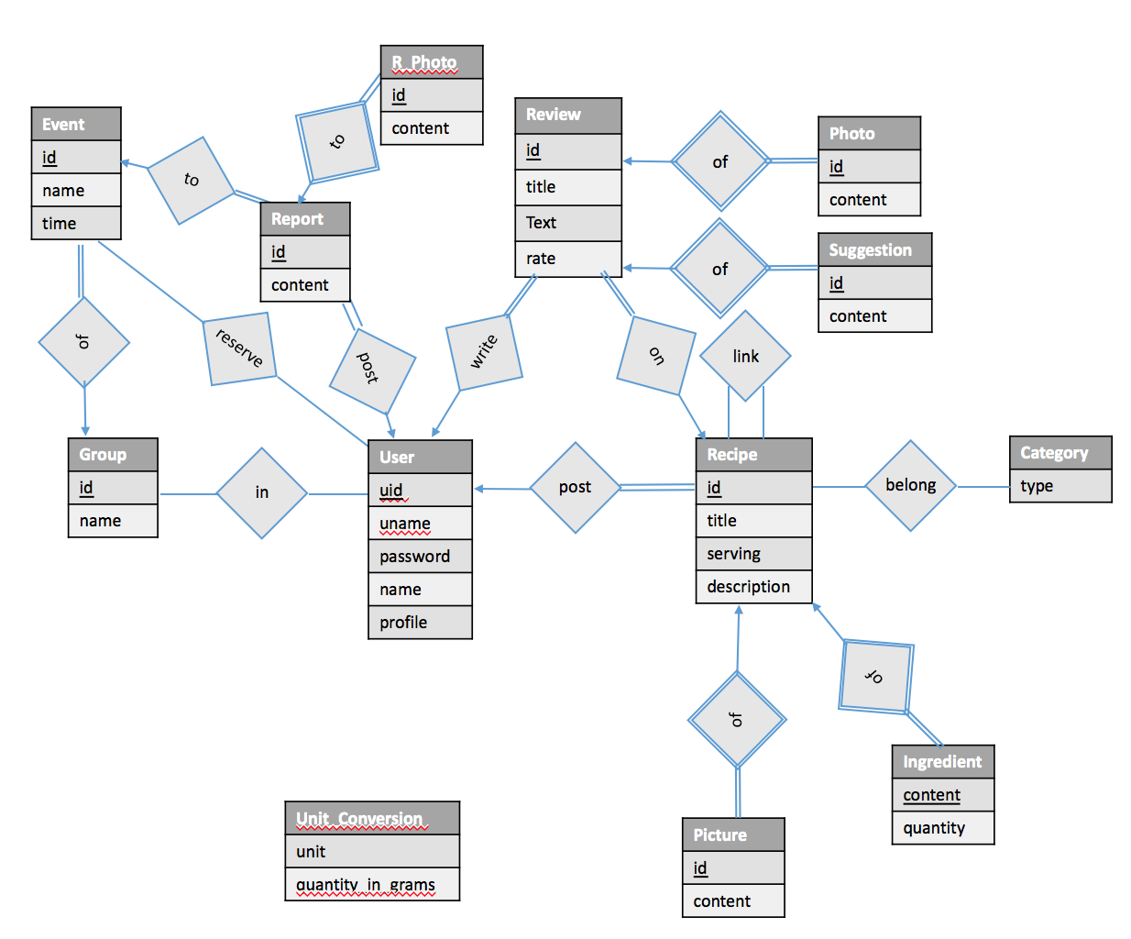

1. Relational Schema

User(uid, uname, upassword, name, uprofile)

Recipe(rid, uid, rtitle, rserving, rdescription)

Recipe_Picture(pid, rid, content)

Recipe_Tag(rid, tid)  
 Ingredient(rid, iname, iquantity)

Link_Recipe(rid, rid_link)

Review(r_id, rid, uid, rrate, rtext, rtitle)

Review_Photo(p_id, r_id, photo)

Review_Suggestion(sid, r_id, content)

Event(eid, gid, etime, elocation, edescription)

GGroup(gid, gname, gnumber, gdescription)

Join_Group(uid, gid)

Report(id, uid, eid, content)

Report_Photo(id, rpid, photo)

Rate(rank)

Unit_Conversion(unit_name, quantity_in_gram)

**Foreign Key References**

Recipe(uid) User(uid)

Recipe_Picture(rid) Recipe(rid)

Recipe_Tag(rid) Recipe(rid)

Ingredient(rid) Recipe(rid)

Link_Recipe(rid, rid_link) Recipe(rid)

Review(rid, uid) Recipe(rid) User(uid)

Review_Photo(r_id) Review(r_id)

Review_Suggestion(r_id) Review(r_id)

Event(gid) GGroup(gid)

Join_Group(uid,gid) GGroup(gid), User(uid)

Report(uid, eid) Event(eid), User(uid)

Report_Photo(rpid) Report(id)

1. **Test Data**
2. **Create Tables and Constraints**

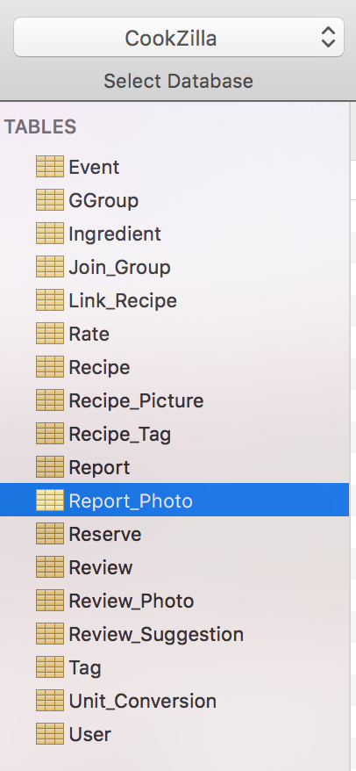

**Event**

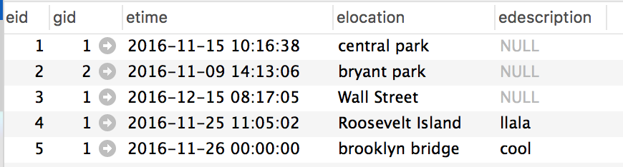

**GGroup Ingredient**

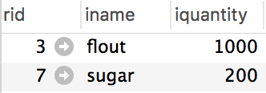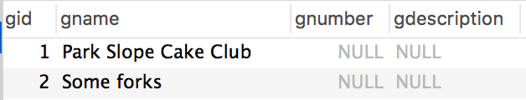

**Join_Group Link_Recipe Rate Recipe_Tag**

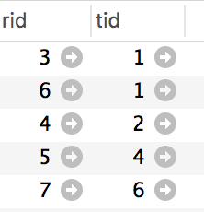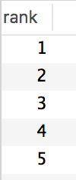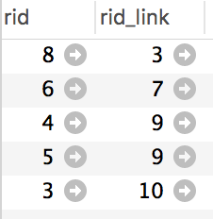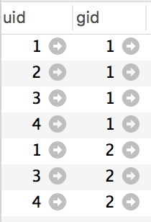

**Recipe**

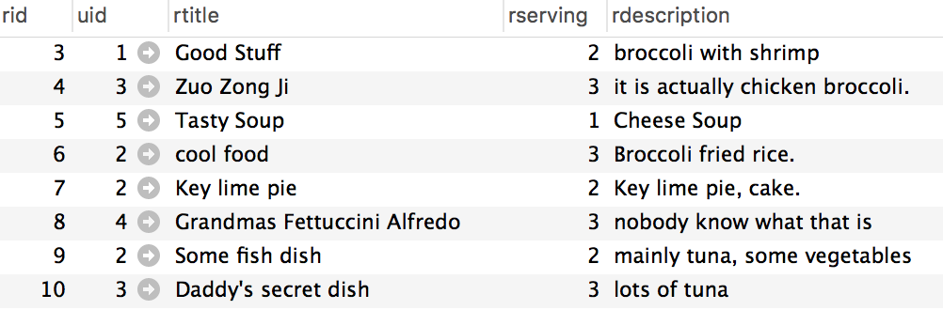

**Report Reserve**

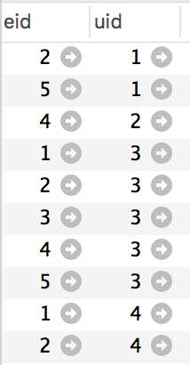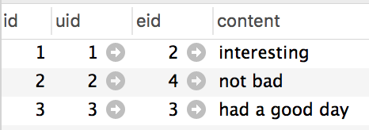

**Review**

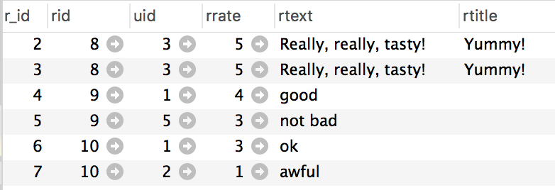

**Review_Suggestion Tag**

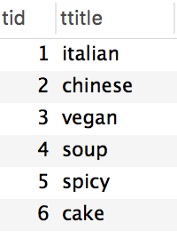 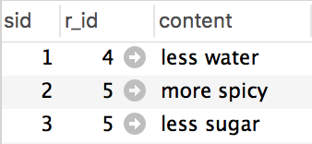

**Unit_Conversion**

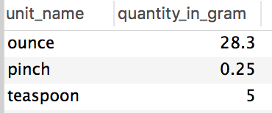

**User**

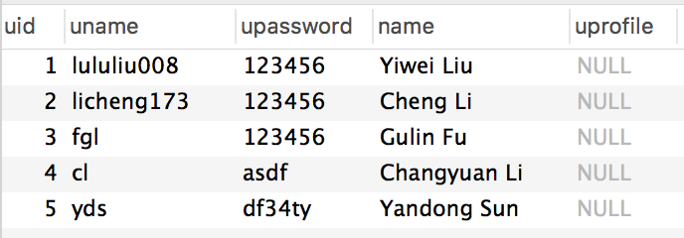

1. **SQL Queries**
2. Create a record for a new user account, with a name, a login name, and a password.

**Insert into** User (uname, upassword, name) **values** ('lululiu008', 123456, 'Yiwei Liu');

1. List all recipes with tag “italian” that contain the keyword ``broccoli’’.

**Select** *

**from** Recipe R **natural** **join** Recipe_Tag RT **natural** **join** Tag T

**where** T.ttitle = 'italian' **and** R.rdescription **like** '%broccoli%';

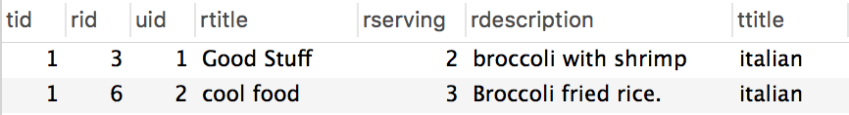

1. List all members of the group “Park Slope Cake Club” that have given a positive RSVP to more that three events of the group.

**Select** name

**From** user **natural** **join** reserve **natural** **join** event

**group** **by** uid, gid

**having** gid = (**select** gid **from** ggroup

**where** gname = 'Park Slope Cake Club') **and** **count**(event.eid) > 3

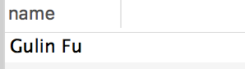

1. List all recipes with tag “cake” that contain more than 50 grams of sugar per serving.

**Select** r.rtitle, r.rid

**From** recipe r **natural** **join** recipe_tag rt **natural** **join** ingredient i **natural** **join** tag t

**where** t.ttitle = 'cake' **and** i.iname = 'sugar' **and** i.iquantity / r.rserving > 50;

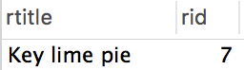

1. Add a review with title “Yummy!”, text “Really, really, tasty!”, and a rating of 5 stars to the recipe for “Grandma’s Fettuccini Alfredo”

**Insert** **into** review (rid, uid, rrate, rtext, rvtitle)

**values** (8, 3, 5, 'Really, really, tasty!', 'Yummy!');

1. List all recipes containing the word “tuna”, sorted from highest to lowest average rating.

**select** r.rtitle, (**sum**(rv.rrate) / **count**(*)) **as** average_rate

**from** recipe r, review rv

**where** r.rid = rv.rid **and** r.rdescription **like** '%tuna%'

**group** **by** r.rtitle

**order** **by** average_rate desc;

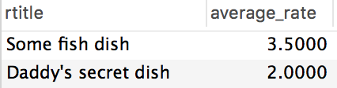

1. List all recipes that are related to a recipe that contains the word “tuna”.

**select** r1.rtitle, r1.rid

**from** recipe r1, link_recipe l, recipe r2

**where** r1.rid = l.rid **and** l.rid_link = r2.rid **and** r2.rdescription **like** '%tuna%';

